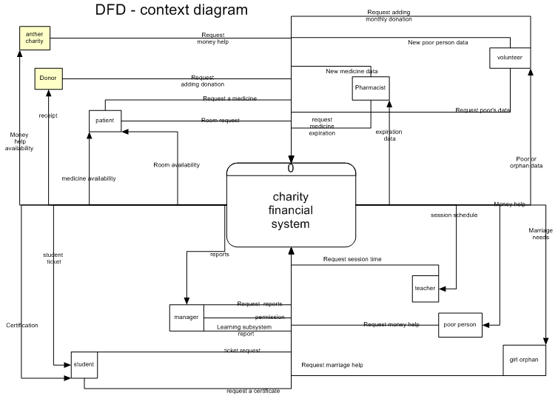

**As we have four to five big subsystem we made overall diagram to all of them**

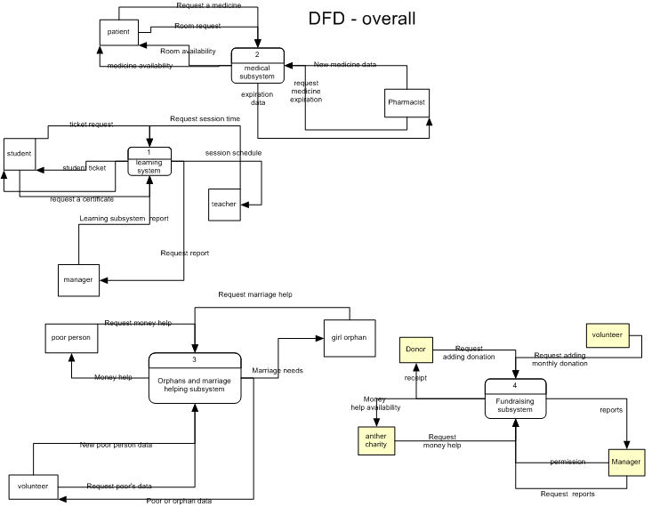

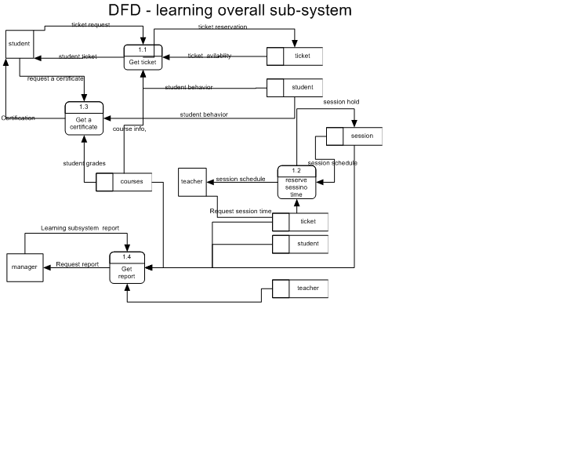

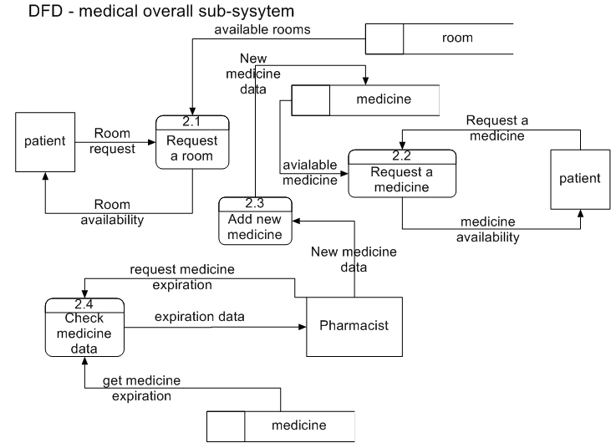

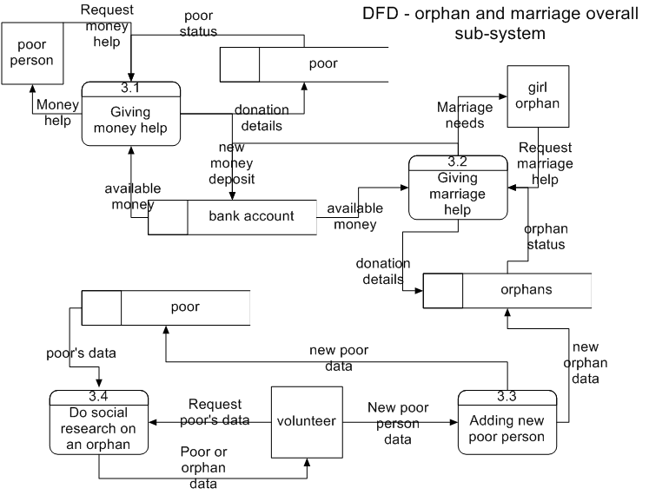

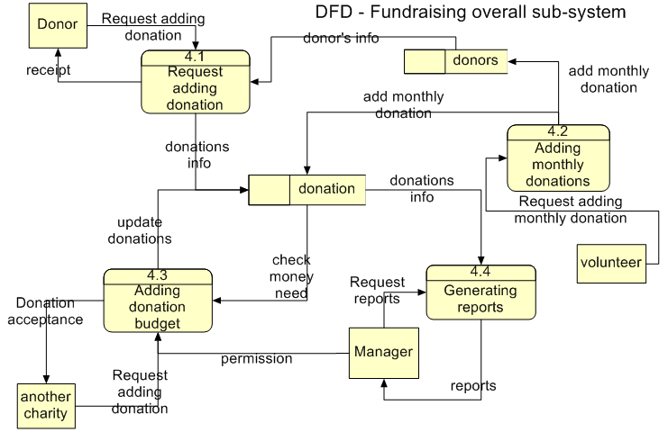

**Detailed DFDs for the learning sub-system with their descriptions:**

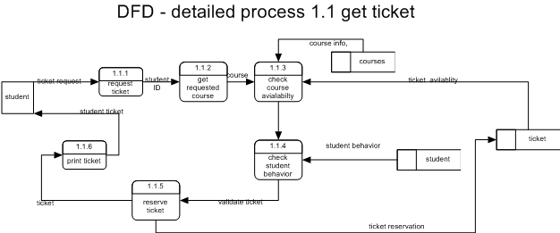

*Process 1.1.4 check student behavior*

*IF student is not successful*

*Announce student he not allowed to register*

*End process*

*Else*

*Validate student behavior*

*End IF*

*End Process*

*Process 1.1.3 check course availability*

*IF course not exist*

*Announce student no such course*

*End Process*

*Else IF course has no free tickets*

*Announce student no free tickets*

*End Process*

*Else*

*Validate course and free tickets*

*End process*

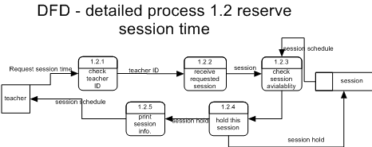

*Process 1.2.3 check session availability*

*IF session time is free*

*Hold this time*

*End Process*

*Else*

*Announce teacher this time is not free*

*End Process*

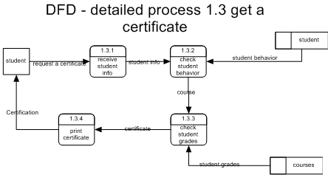 **Detailed DFDs for the medical sub-system with their descriptions:**

*Process 1.3.3 check student grades*

*IF course not exist*

*Announce student no such course*

*End Process*

*Else IF student failed the exam*

*Announce student he have failed the exam*

*End Process*

*Else*

*Validate course and certificate info*

*End process*

*Process 1.3.2 check student behavior*

*IF student is not successful*

*Announce student he not allowed to register*

*End process*

*Else*

*Validate student behavior*

*End IF*

*End Process*

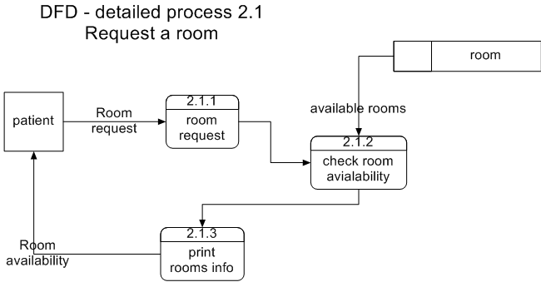

*Process 2.1.2 check room availability*

*IF room is free*

*Hold this room*

*Else*

*Announce user this room is not free*

*End Process*

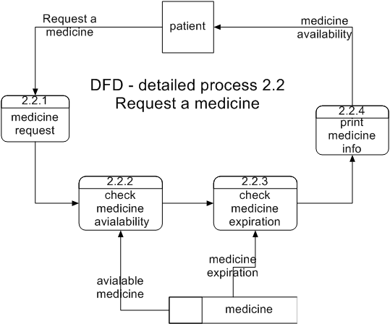

*Process 2.2.3 check medicine expiration*

*IF medicine is not expired*

*Hold this medicine*

*Else*

*Announce user medicine is not expired*

*End Process*

*Process 2.2.2 check medicine availability*

*IF medicine is available*

*Print no of items*

*Else*

*Announce user medicine is not available*

*End Process*

**Detailed DFDs for the marriage and orphans helping sub-system with their descriptions:**

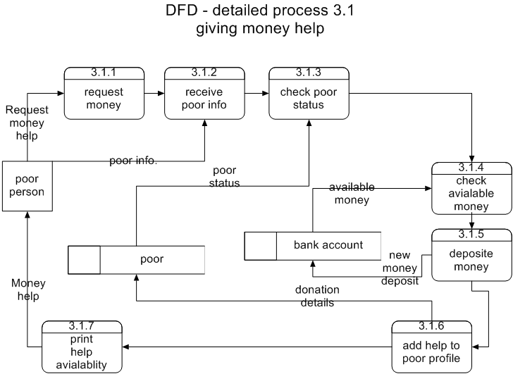

*Process 3.1.3 check poor status*

*IF poor is really in need*

*Continue request procedures*

*Else*

*Refuse money request*

*End Process*

*Process 3.1.4 check money available*

*IF money is available*

*Accept money request*

*Else*

*Refuse money request*

*End Process*

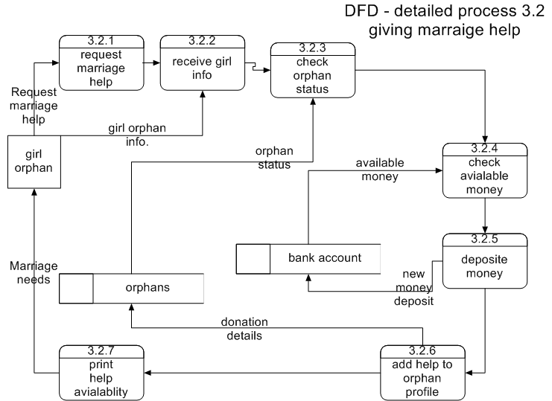

*Process 3.1.3 check orphans status*

*IF orphan is really in need*

*Continue request procedures*

*Else*

*Refuse help request*

*End Process*

*Process 3.1.4 check money availability*

*IF money is available*

*Accept this help request*

*Else*

*Refuse money request*

*End Process*

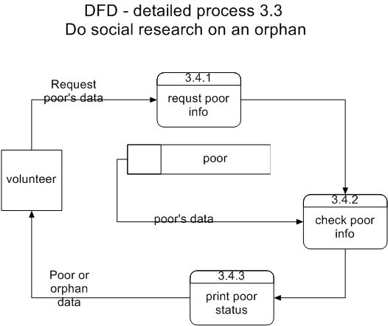

**Detailed DFDs for the marriage and orphans helping sub-system with their descriptions:**

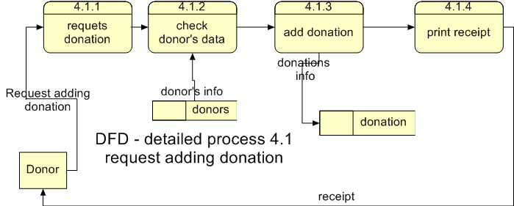

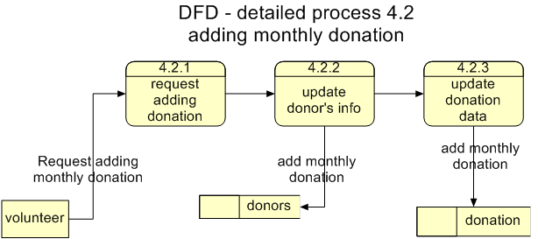

*Process 4.1.2 check donor’s data*

*IF donor is registered*

*Accept donation*

*Else*

*Ask donor to register*

*End Process*

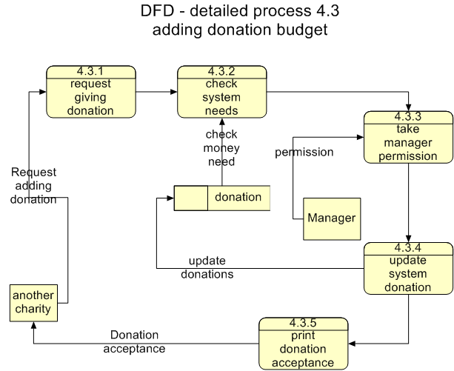

*Process 4.3.3 check manager permission*

*IF manager accepts donation*

*Accept this donation*

*Else*

*Refuse donation*

*End Process*

*Process 4.3.2 check system needs*

*IF system has needs*

*Ask for manager permission*

*Else*

*Refuse help*

*End Process*

**Chapter 3**